It is time for week 6 of the Silly Squad summer reading challenge. This week our story is Superworm by
Julia Donaldson.

Superworm just isn’t your typical superhero, he does not have massive muscles. He is super-skinny but, not weedy at all! When trouble strikes, this worm is brave, this worm is kind, this worm is super helpful. This is Superworm!

I hope you enjoy the story.

First, it is time wake your bodies up!

Activity 1: 7 minute HITT workout for children p2

For anyone who needs a little help or, would like a more gentle workout, ask a partner to help you with:

Activity 2: Garden Yoga p3

Activity 3: Sharing a digital story:

Superworm by Julia Donaldson

1. Click on the Youtube link below; watch and listen to the
story:

https://www.youtube.com/watch?v=4nH1FGYYA3E

2. Don’t forget to fill in your story record sheet.

3. Do you recommend this story: Yes / No
Activity 1: 7 minute HITT workout for children

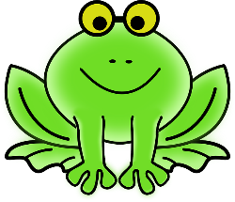 | Frog jump | Hop, hop, hop backwards and forwards like a frog
 | Bear walk | Hands and feet on the floor, hips high, walk left, walk right. Walk like this for 1 minute.
 | Gorilla shuffle | In a low sumo squat, use your hands to balance and shuffle around the room
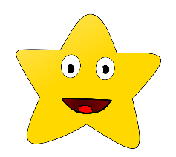 | Star fish jumps | Spread your arms and legs wide and jump up and down.
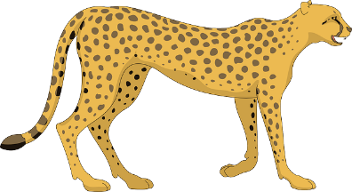 | Cheetah run | Run on the spot as fast as you can. Try and run for a minute.
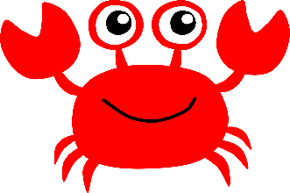 | Crab walk | Sit down, place your palms on the floor. Lift your hips up and  walk on your hands and feet.
 | The elephant stomp | March around, the room or the garden stomping your feet.
Activity 2: Garden yoga poses
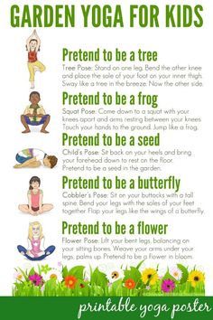

Activity 4: Superworm playdoh

You will need:

Playdoh or salt dough (see recipe below for salt dough p5)
Pencil or kebab stick (for making markings)
Ruler
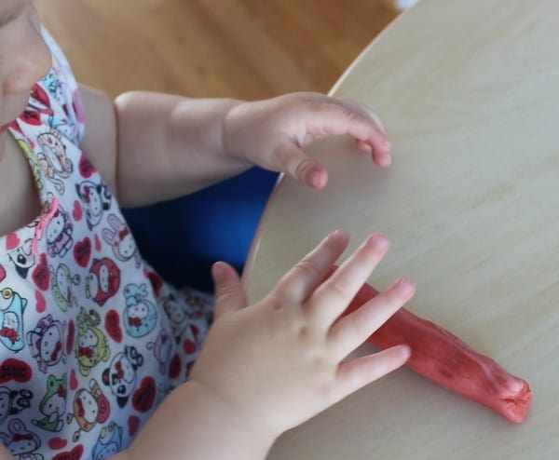

- Roll your playdoh into a long sausage
squeeze him, stretch him.

- Shape your worm’s head and tail

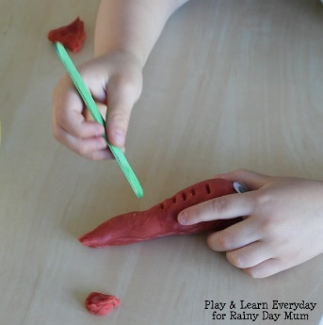

- Use something with a point to make
markings on your worm’s body

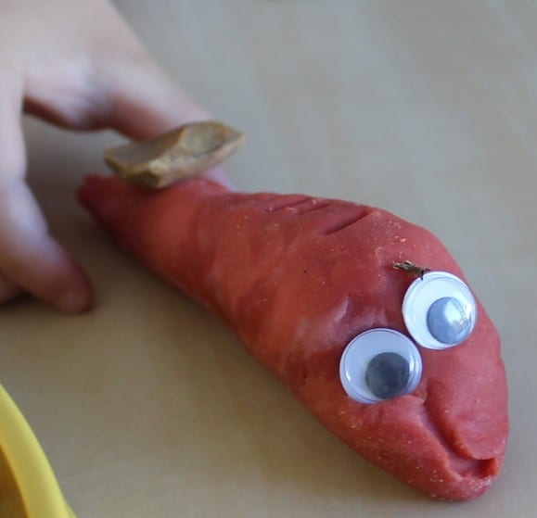

- Give your worm some eyes. If you do not
have googly eyes, use your pencils or playdoh to
make eyes

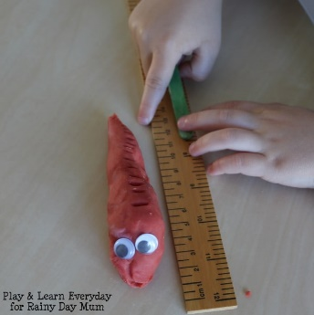
- Measure your worm. How long is he?

My worm is: _________cm

Recipe for Salt dough:

You will need:

1 cup of flour
½ cup salt
½ cup water
a squirt of washing up liquid

Method:

Pour all the ingredients into a bowl and mix well to form a stretchy dough

Activity 5: Making Jelly worms

You will need:
A jar
Plastic straws
Jug
Jelly
Warm water
Dish

Method:

1. Stand your straws in a
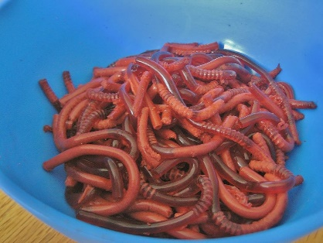
glass jar
2. Fill your straws with jelly
3. When set, pour warm
water over the straws to
loosen the jelly
4. Put your worms in a dish
5. Enjoy playing with your worms

Stretch them, squeeze them. Make them into hats, skipping ropes, belts, even taste them!
Activity 6: Washing up

- Put all your dirty things in the sink
- Put any rubbish in the bin, remember to recycle
- Wash up all your equipment
- Use a cloth to wipe the table
- Check the floor and clear up any mess
- Wash your hands and put everything away

Activity 7: Me time – time to smile

- Find a quiet place, somewhere you like to be
- Sit down, lie down if you prefer
- Close your eyes
- Think of something that makes you happy and
- Smile
- How do you feel now?

The next time you see someone smile.

When you smile, even a fake smile, your brain releases feel-good chemicals making both you and those around you feel better. Try and do this everyday!

I hope you enjoyed this week’s story. Keep reading and sharing your stories

