Ladybird

Stories
- What the Ladybird Heard – Julia Donaldson
- The bad tempered ladybird – Eric Carle
- The very lazy ladybird – Isabel Finn and Jack Tickle

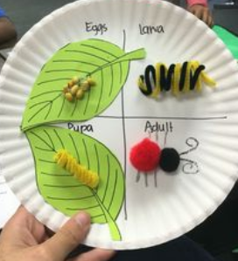
Activities
- Make a ladybird life cycle
- Make a ladybird out of a toilet roll
- Go on a ladybird hunt and identify the
different types of ladybird you find
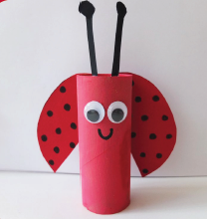
- Paint stones to look like ladybirds
(use acrylic paint or normal paint and cover in a varnish and they can go outside)
- Twinkl has lots of ladybird themed activities
(if you have a printer at home)
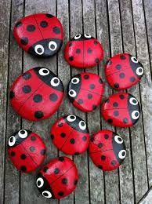
- Make a ladybird fact file – where do they like
to live? What do they eat? How long do they
live for? How many different types of ladybird
are there?

