Birds
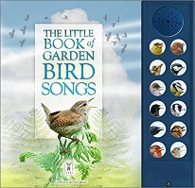
Stories
- The Little book of Garden bird songs
A press the button book to learn which bird song belongs
to which bird – available from Amazon and other retailers
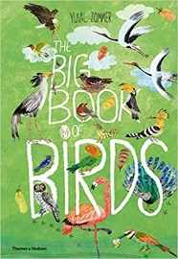
- The big book of birds – Yuval Zommer
- Owl babies – Martin Waddell & Patrick Benson
- The Messy Magpie – ebook available on Twinkl
Activities
- Make a bird bath
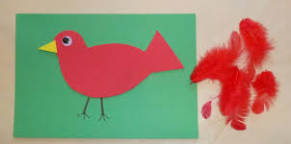
https://www.rspb.org.uk/get-involved/activities/give-nature-a-home-in-your-garden/garden-activities/maketheperfectbirdbath/
- Plant sunflowers for birds to eat the seeds
- Build a nest in the garden
What do you need to make a cosy bird nest? Can you make a giant nest (if you walk in a nature area)? How many people can fit in it
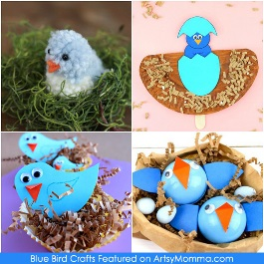
- Make a feathered bird.
Rainbow or colour match feathers to a bird outline
- Make a pompom bird (like an angry bird)
- Make a flapping bird
https://www.artistshelpingchildren.org/kidscraftsactivitiesblog/2012/03/how-to-make-a-flying-bird-decoration/
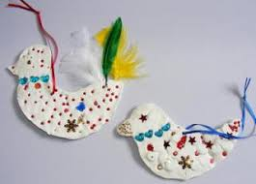
- Bird comprehension worksheets
- Sew a bird using scraps of material and
different stiches to create detail
- Bird themed snacks – can you make your food look like a bird or a nest? 