Pond life

Stories
- Wind in the Willows – Kenneth Grahame
- Life in the pond - https://www.storyjumper.com/book/read/25290168/Life-in-the-Pond#page/3
- The wide mouthed frog – Jonathon Lambert
Activities
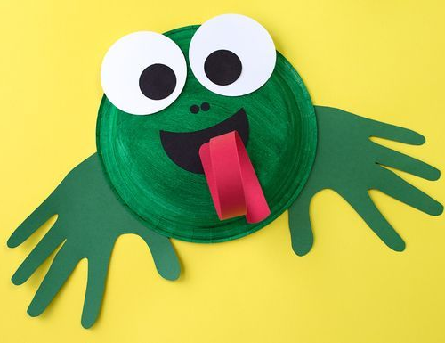
- Make a mini pond in your garden
- Identify the different species which
visit your pond
- Make a paper plate or egg carton frog
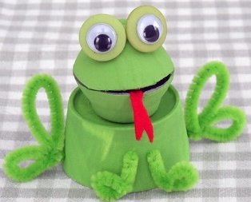
- Investigate the frog lifecycle and complete a worksheet
- Make an origami frog
- Play “cross the pond” game
- Paint a stone to look like a frog
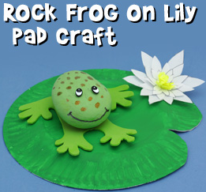
- Twinkl has lots of frog and pond themed
activities (if you have a printer at home)

