Weekly Challenges
Dalmatian home learning
Week Beginning 4th May

Hello Everyone,

I hope you enjoyed last week’s challenges and all your socks are organised! Thank you as ever for all the lovely videos and pictures: we are still missing you all a lot so it is lovely to see your faces.
If you have completed a different activity at home that has gone really well, please do share it. Equally, if you need more information about the challenges, do get in touch.

Keep an eye on your emails this week: the Dalmatian team and I are working on a special video surprise for you all!

In the meantime, stay safe and well and please do email me pictures!
kblack@granta.cambs.sch.uk

Katie and the Dalmatian team.

- Make your own paintbrush
You will need:
pegs
a variety of materials
paints
paper
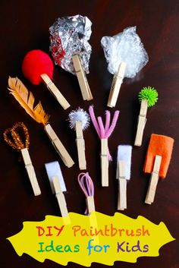

Can you choose some different materials to put in your pegs?

Create your paint brushes and have fun using them to paint!

Language and Communication
Using the PECs sheet, model making the sentence ‘I want orange’ by pointing to the relevant symbol. Encourage your child to do the same!

- Lid matching

You will need:
A variety of containers and lids
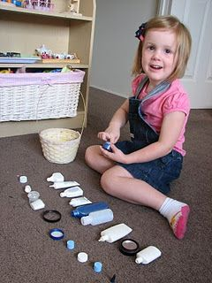

Another maths/life skill activity. Remove the lids and mix them up initially. Model the activity and, if this is particularly challenging for your child, start with just one container and one lid, building from there!

- Coin sorting!
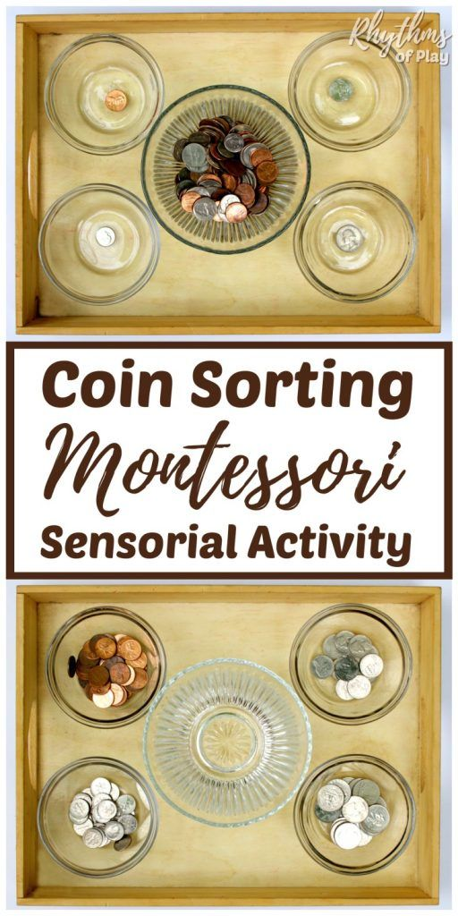

Coins are a relatively new concept to us in class! The above set up is a good way to start. As always, model the activity first. I’ve attached a sheet to support the activity.

- Writing in flour
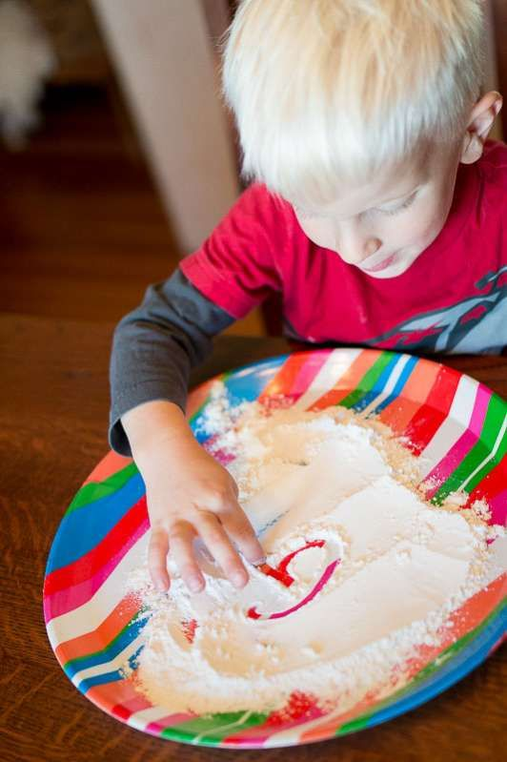

You will need:
A non-white surface!
Flour
Help your child to make a variety of marks/letters in the flour using their in

- Phonics lesson on the website.
You will need:
PECs symbols
Paper/whiteboard
Pen

Watch the lesson here:

https://vimeo.com/413549617

Hopefully this is fairly self-explanatory and will be a familiar format to some Dalmatian students. Don’t worry if your child doesn’t engage with it: Dalmatian students are all at slightly different stages of the phonics programme we run (it’s not a specific programme, just one that we have created!) I will post an environmental sound phonics lesson next week.

Remember to email your pictures to kblack@granta.cambs.sch.uk I absolutely love seeing them!

