Weekly Challenges
Dalmatian home learning
Week Beginning 29th June

Hello Everyone,

Here’s another set of challenges for you. As usual, please do email me pictures! Get in touch with me if you need to at any time.
kblack@granta.cambs.sch.uk

Katie and the Dalmatian team.

- Make a Pirate’s telescope!
You will need:
A toilet roll tube
A paper cup
Some decorating materials

Attach your cup to the end of the tube and decorate it. What can you see through your telescope?

- Ten Little Pirates
You will need:
Here is a video of Katie reading our new Pirate story – Ten Little Pirates! How many pirates can you count? Can you sign pirates?

https://vimeo.com/433963482

https://www.bbc.co.uk/cbeebies/watch/something-special-pirate-ship-flag-treasure

- Pirate Counting Sheets
The attached pirate counting sheet

How many pirate themed items can you count? Can you find or write the correct number? Good luck!
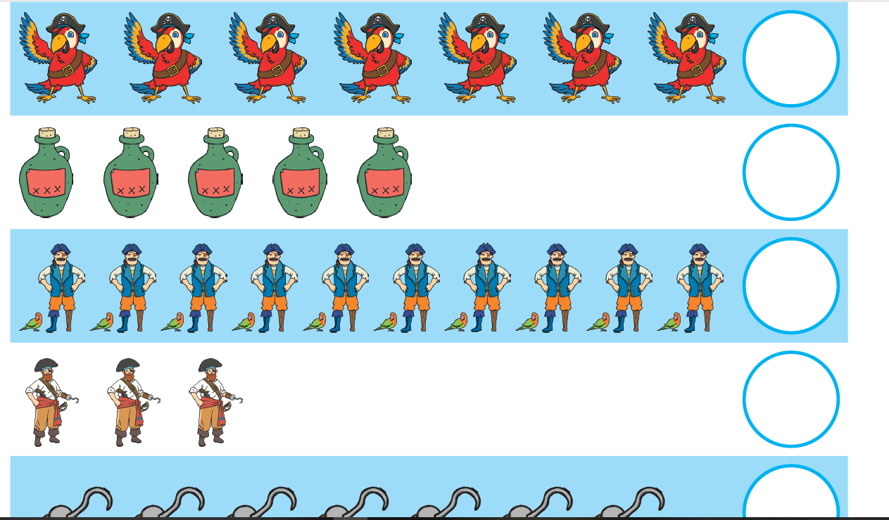

- Octopus tentacle counting
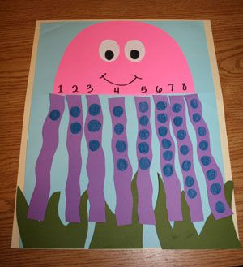

You will need:
An octopus template
8 tentacles
A pen or some cut out circles to make your dots!

Can you make an octopus? How many legs do they have? Put the numbers in order and the correct amount of dots to each tentacle

Remember to email your pictures to kblack@granta.cambs.sch.uk I absolutely love seeing them!

