KS4 – Home Learning Activities

Heating water using the sun- Investigation
Do you have a paddling pool?
Did you know that you can heat up the cold water using black bin bags?
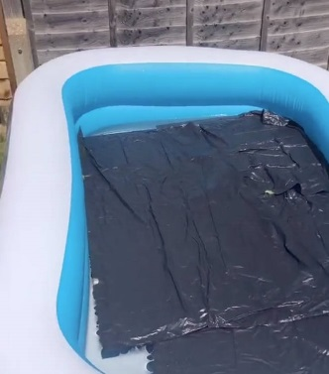
Why not try an investigation to see if it works?
Take two bowls (the same size). Fill them with the same amount of cold water.
Put a piece of black bin liner in one.
Leave both containers in the sun for an hour or two.
Feel the water, which is the warmest?
The science
The heat from the sun is called infra-red radiation.
Read more…
Read sheet 2A
Complete sheet 2B

