Hello everyone,

It is time for week 3 of the Silly Squad summer reading challenge. This week our story is Kitchen Disco by Clare Foges. Have you ever wondered what the fruit in your fruit bowl do when you are tucked up in bed? Listen to the story to find out.

First, let’s get out bodies moving. Your body will need to be warmed up for Activity 6.

Activity 1:

Time to get active with Joe Wicks:

https://www.youtube.com/watch?v=u0_1QBQ8Syk JW

Next, choose one activity to do in Activity 2.

Activity 2: Apple crafts (if you do not have apples you
can use any fruit or vegetable that you have)

Choose one of the craft activities below to do.

You will need:

Paper or paper plate
Paint / felt tips (if you do not have paint, add a little food
colouring to some water. Or use your felt tips
or crayons to draw your own picture)
Glue
Scissors

Lady bug apple print

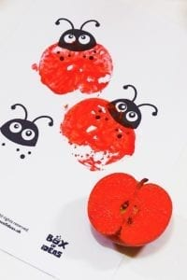
1. Cut your apple in half
2. Put a little paint on a plate
3. Press the cut side of the apple into
the paint
4. Press the painted side onto to the
Paper to make some prints
5. Use a black felt tip or crayon to
draw on the head and spots

Hungry caterpillar

1. Paint or colour your plate red
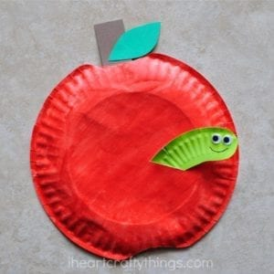
2. Cut a little piece off the
top and the bottom of the plate
(see picture)
3. With adult help, cut a caterpillar
shape out of a piece of paper and
colour it green
4. Cut out a leaf and a stalk. Colour
these
5. Glue your leaf, stalk and caterpillar
onto your apple

Fruit pattern prints or picture

1. Mix up some paint (or use crayons or felt tips)
2. Cut some fruit or vegetables in half
3. Make a print pattern on your paper, or draw your own picture
Activity 3: The big tidy up

- Put all the fruit in the bin / compost bin
- Collect all the dirty equipment and put them in the sink
- Do the washing up
- Wash your hands
- Wipe the table with a clean cloth
- Put your crayons / felt tips away
- Put your amazing art work somewhere safe to dry
- Have a good look around, have you forgotten anything?

Activity 4: Getting ready for a disco

Imagine you are going to a disco or a party. To get ready, what would you need to do? Perhaps:

Check in the mirror, is your face clean? Are your hands clean? If you answered ‘no’. Go and wash your hands and face. Don’t forget to dry them well.

Now wander round your home and find five things you need to do to get ready for the disco or a party. You could collect:

- a brush, to brush your hair
- your favourite T’shirt to wear
- clean socks, no one likes smelly feet
- a cloth or duster to clean your shoes or trainers
- the picture you painted or your print to give to a special person to say thank you

Activity 5: Sharing a digital story:

Kitchen disco by Clare Foges and Al Murphy.

1. Click on the Youtube link below; watch and listen to the
story:

https://www.youtube.com/watch?v=1HvtPtcUC_U

2. Fill in your story record sheet.

3. Do you recommend this story: Yes / No

4. If you share a story or read a book at home, add it to
your reading record. If you enjoyed this story, let
your teacher know.

5. Keep reading and sharing stories

Activity 6: The family conga

https://youtu.be/h113zPM-Zkc

Just like the grapes, it is time to do the conga. Get you family on their feet. Form a line one behind the other, with you at the front. Now take them around the house doing the family conga. Have fun.

Remember: 1 / 2 / 3 … conga

You have worked really hard, now it is time for Me time.

Activity 7: Me time

If you can, go out into the garden, lie down and look at the sky. Take a cover to lie on if you want to and maybe something special with you.

Lie down on your cover and look up at the sky. Look really hard. What colour is the sky? Blue? Grey? A little bit yellow?

Can you see any clouds? What do they look like? Are they big and fat and fluffy, like big balls of cotton wool?

Are they thin and wispy like feathers?

Are they all different colours? Does it look like they are full of rain?

Are the clouds hanging over your head? Floating by slowly or, are they moving very fast?

Lie still for a moment. What shapes can you see?

Close your eyes and count yourself down: 5 / 4 / 3 / 2/ 1.

Silly Squad 3 has finished, I hope you had fun.

