Hello everyone,

It is time for week 2 of the Silly Squad summer reading challenge.

Activity 1:

Time to shake your sillies out:

Let’s get physical, time for Shake your sillies out exercize 1 (2.40 minutes).

https://www.youtube.com/watch?v=NtsoBRcV-qE

- Choose one activity from either Activity 2 / 3 or 4 to do.
- Watch / listen to the story. Click on the link in Activity 5.

Activity 2:

Make your Balancing robot:

Materials

Card
Robot template
Crayons
Blu tak / play doh / plasticine or tape
Scissors

- Stick your robot template on to a piece of card. If you do not have any card, you could use a cereal box
- Colour in your robot
- Use your scissors to cut it out. Ask an adult to help you.
4. Now assemble your robot. Follow the instructions below:

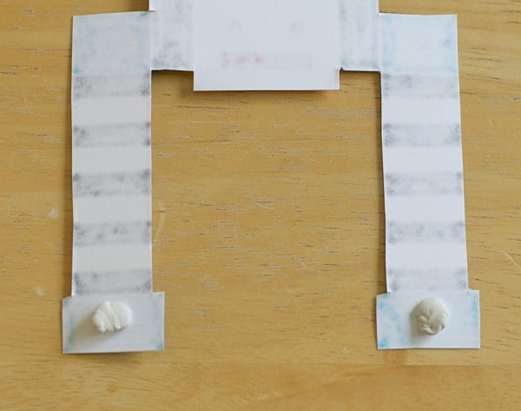
Turn one of your robots over and stick a piece of blu tak on to each hand

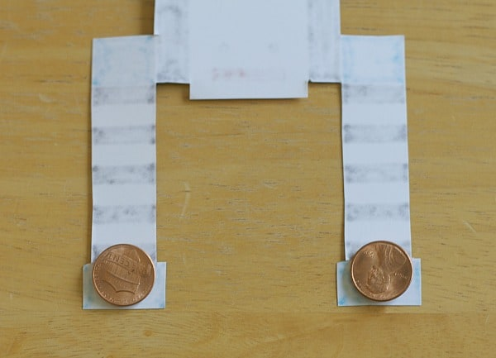
Press a penny on to each blob of blu tak

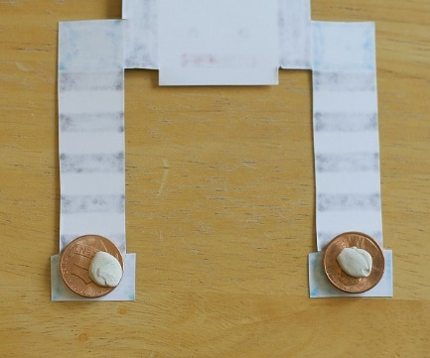
and then stick a piece of blu tak on top of
your pennies

put a piece of blu tak onto the back of the
head and lay the second robot on top.
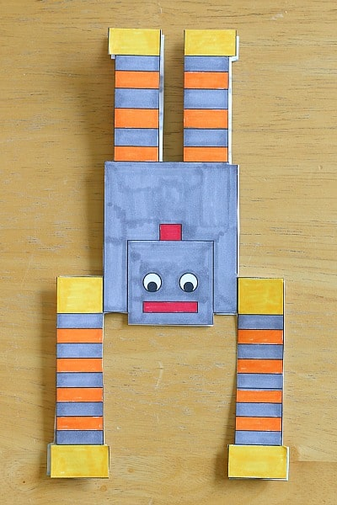
Press down gently to secure.
Now you are ready to test your balancing
robot

Activity 3: Game - Build your robot

To play you will need:

The game board
Robot body pieces template
Dice

- Cut out your robot body parts
- Collect your dice
- Throw your dice and begin to build your robot

Balancing robot template
Robot body parts template

Legs
Head
Body
Face
Arms
Antenna
Build your robot game
You will need a dice to begin to play

Activity 4: Shape match
triangle

Use a pencil to join the correct name to the correct shape.

circle
rectangle
square
Activity 5: Sharing a digital story:

Our story this week is: Nobot, the robot with no bottom by Sue Hendra.

1. Click on the Youtube link below to hear the story:

https://www.youtube.com/watch?v=EL1sTiqdTJg

(move the slider to .30secs to skip the introduction)

2. Fill in your story record sheet.

3. Do you recommend this story: Yes / No

4. If you share a story or read a book at home, add it to
your reading record. If you think it is really funny, let
your teacher know.

5. Keep reading and sharing stories

Have fun.

