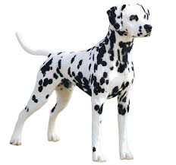
Weekly Challenges
Dalmatian home learning
Week Beginning 22nd June

Hello Everyone,

Here are this week’s challenges: the weeks seem to be flying by! I hope those of you who are at home are well. We are missing the Dalmatians we haven’t seen in a while!
Again, please do email me pictures! Get in touch with me if you need to at any time.
kblack@granta.cambs.sch.uk

Katie and the Dalmatian team.

- Colour Sorting activity
You will need:
The colour sorting sheets attached to the email
A variety of colourful objects from around the house
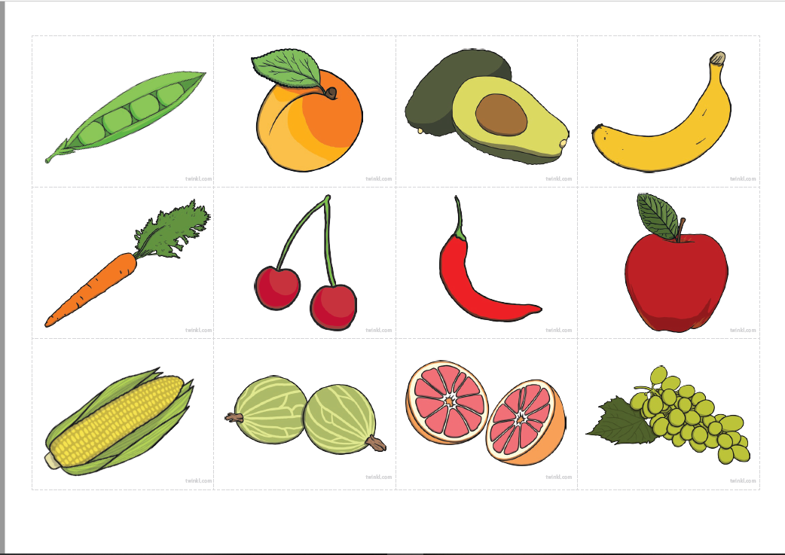

Sort the printable foods by colour, encouraging your child to say the words as they sort them.

Extension:

Go on a colour hunt around the kitchen and sort those objects too! Can your child match the symbol, colour and real life object?

- Beautiful creatures art
You will need:
Some compost or mud
A variety of junk modelling items

Here is a video for you to watch on how to complete this task. It was made by the oak academy, the national response to online learning and is specifically for students with SEND. They’re much more professional than my videos!
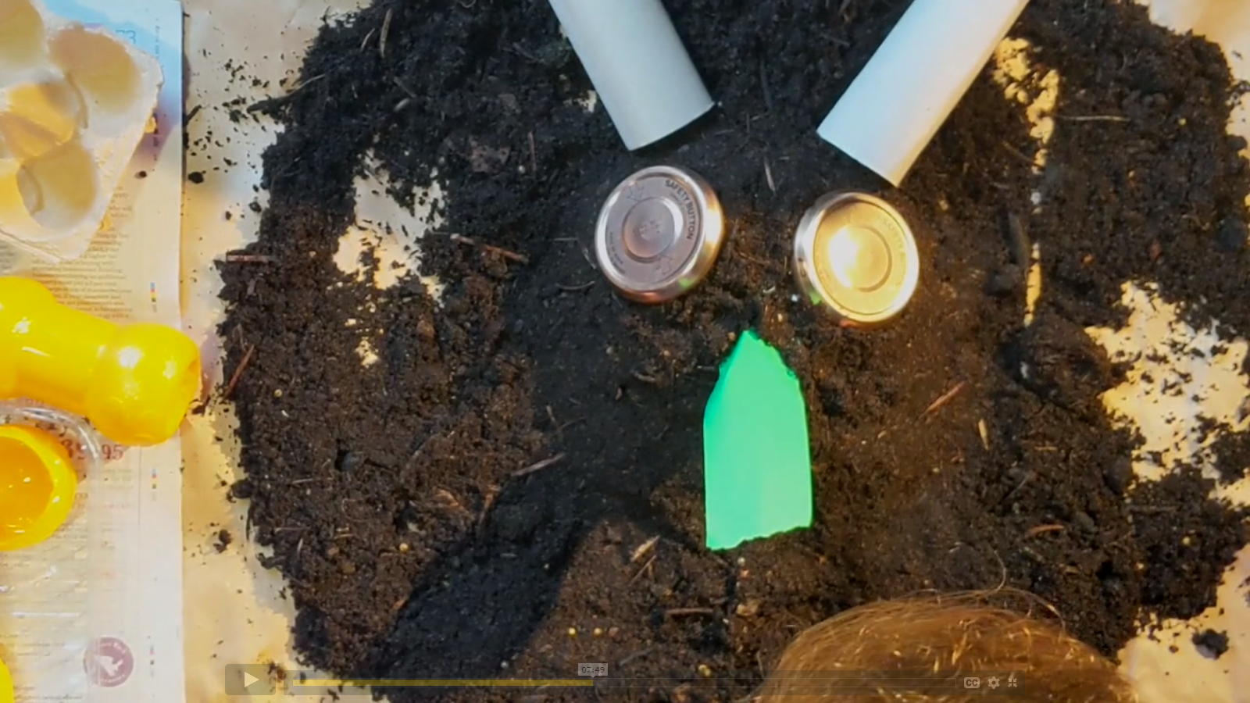

https://classroom.thenational.academy/lessons/beautiful-creatures/activities/1

- Attention Autism - suncream
You will need:
A sun hat
Some sun screen
A mirror
The video link

Watch the video link and follow along with the actions! This can be repeated many times and can work very well in promoting independence and self-help skills.

https://vimeo.com/431783779

- Pirate Yoga

You will need:
Some space and a screen!

https://www.youtube.com/watch?v=T_0P5grVoyg

We regularly use Cosmic Yoga in the classroom. It’s quite challenging for everyone (adults included!) but it can offer some fun massage opportunities with your child. You could help them to get into different positions, if a move focusses on legs but is quite tricky, you could massage your child’s legs. Do what you can and don’t feel you need to do it all: I certainly can’t!

- Rainbow Fruit Kebabs
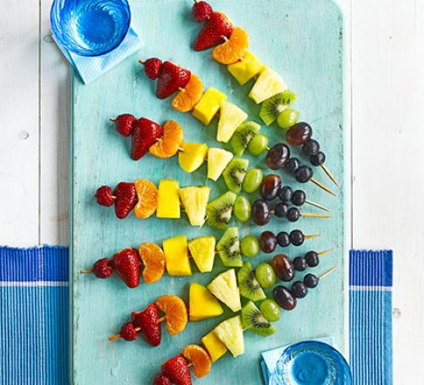
This is a lovely self-help/fine motor activity. Use kebab skewers to thread your fruit to make colourful kebabs.

Remember to email your pictures to kblack@granta.cambs.sch.uk I absolutely love seeing them!

