- empty soda can  - blown-up balloon  - your hair | 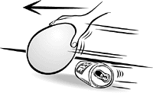

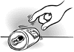  Put the can on its side on a table or the floor -- anyplace that's flat and smooth. Hold it with your finger until it stays still.  Rub the balloon back and forth on your hair really fast.  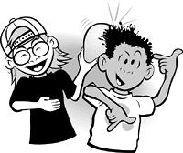  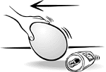  Hold the balloon about an inch in front of the can. The can will start to roll, even though you're not touching it! | 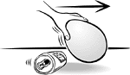  Move the balloon away from the can -- slowly -- and the can will follow the balloon.  If you move the balloon to the other side of the can, the can will roll in the other direction.  How fast will the can roll? How far can you roll it before the can stops? Will it roll uphill?  If you have some friends with cans and balloons, you can have a race across the room or down the sidewalk

