Weekly Challenges
Dalmatian home learning
Week Beginning 27th April

Hello Everyone,

I hope you enjoyed last week’s challenges. Thank you for all the lovely videos and pictures: we are missing you all a lot so it is lovely to see your faces.
If you have completed a different activity at home that has gone really well, please do share it. Equally, if you need more information about the challenges, do get in touch.

In the meantime, stay safe and well and please do email me pictures!
kblack@granta.cambs.sch.uk

Katie and the Dalmatian team.

- Sock matching challenge
You will need:
A variety of socks
Lots of patience!
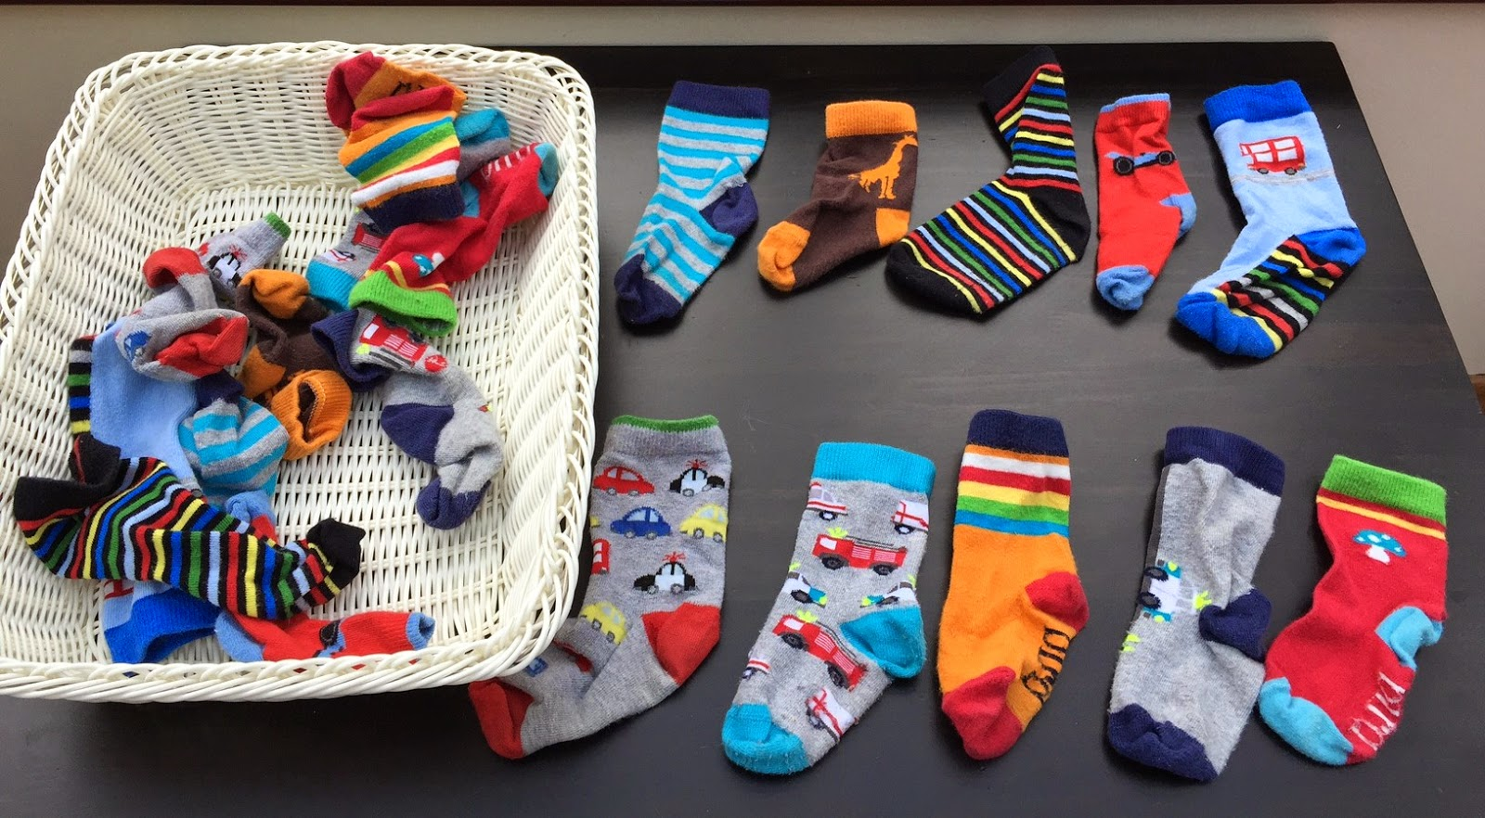
Can you find a pair of socks? Socks that are the same?

Language and Communication
Use simple language such as ‘find the same’. Demonstrate the activity. Give targeted praise ‘well done, you found the same!’

This is a great ‘like for like’ task that also works on important life skills.

- Lego number line challenge

You will need: duplo, lego or any object
Written numbers
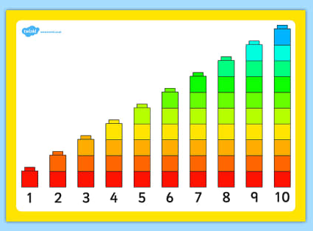

I have attached the above sheet for you. This activity works on cardinal understanding of number i.e quantity. Lego is the perfect resource but if you don’t have any, you can use blocks or any other toy. You could even use stones from the garden!

It is good to demonstrate the activity first, counting out each item.

Happy counting!
- Sunflower toilet roll painting
Watch the video on the website:

https://vimeo.com/412219763

Again, model the activity and encourage your child to do it as independently as possible.

I’ve attached colour symbols for you to use if you need them!

- Plant a sunflower!
You will need:
A plant pot or recycled yoghurt pot or something similar
Compost or soil
Water
Sunflower seed (I’ve posted some sunflower seeds to you)

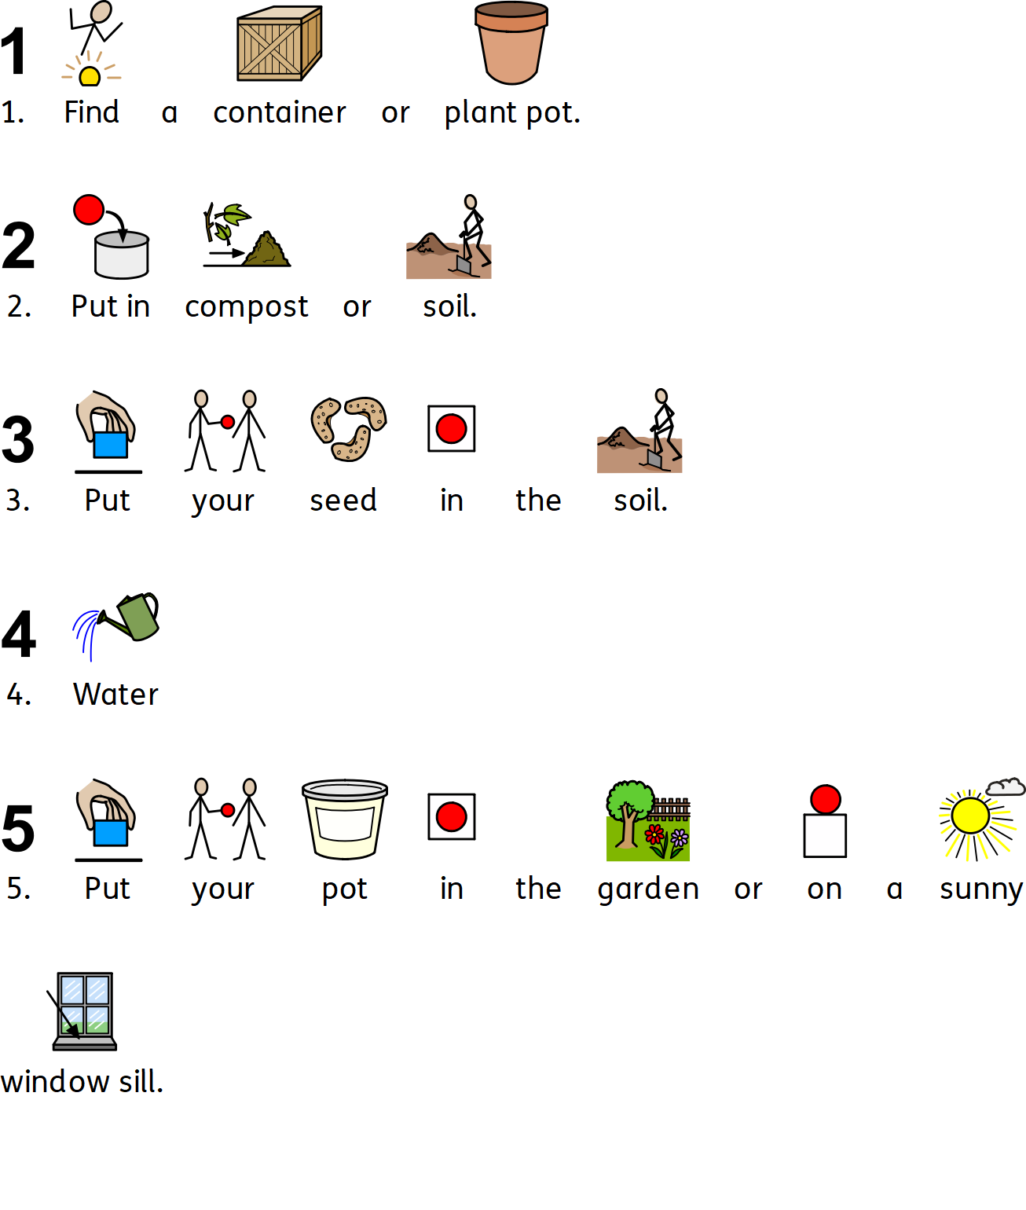

- Sound Discrimination game for computer or tablet

https://www.phonicsbloom.com/uk/game/match-sounds?phase=1

This is a lovely sound discrimination game for environmental sounds that will work on a tablet too. You drag the correct sound to the top of the screen so it is a good for developing ICT skills too. Every child in Dalmatian has a daily sound discrimination activity and are very good at discriminating between environmental sounds.

Remember to email your pictures to kblack@granta.cambs.sch.uk I absolutely love seeing them!

