Trees
Stories
- Tree: Seasons come, seasons go – Patricia Hegarty
- The Great Kapok Tree – Lynne Cherry
- Leaf man – Lois Ehlert
- Stickman – Julia Donaldson
- Not a stick – Antoinette Portis
- The stick book – Jo Schofield
- Outdoors and Up for it – free activity book from Archimedes (company who provided Steph’s Forest School training) https://www.forestschools.com/collections/free-training/products/outdoors-and-up-for-it-free-book?variant=16347604844595
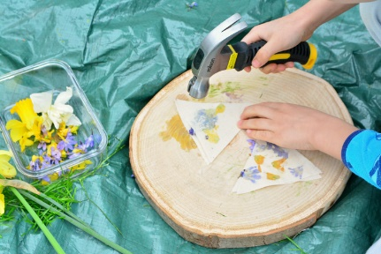
Activities
- Hapa Zome (leaf and flower printing)
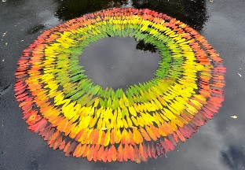
- Collect a range of leaves, sticks and flowers
can you make a picture using them?
can you make a picture of your favourite story?
- Make a family tree
- Andy Goldsworthy leaf art – uses leaves to
create giant artwork
- Make an animal out of leaves
- https://blog.stihl.co.uk/10-native-uk-trees-download-your-free-worksheets-here/
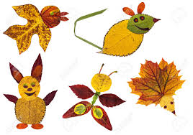
explore British trees and made a fact sheet - 10 to download
- Leaf and bark rubbing with crayons
- Make a stick mobile
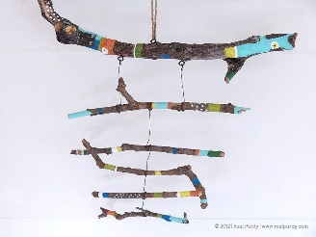
- Make a sticky weed crown
- Sensory sorting – sorting natural items into
groups (e.g. leaves, sticks, stones, acorns)

